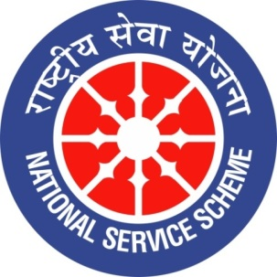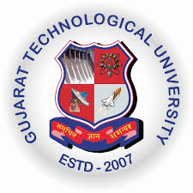
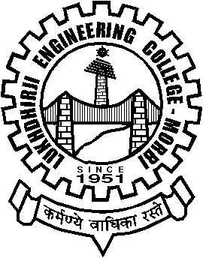
GUJARAT TECHNOLOGY UNIVERSITY
NATIONAL SERVICE SCHEME
Lukhdhirji Engineering College-Morbi
A Report on MATDAR SUDHARNA PROGRAMME-2021 on 25/1/2021 of L.E.College-Morbi

NSS Unit Name/College Name: L.E.College-Morbi
Event NAME: MATDAR SUDHARNA PROGRAMME-2021
Event Date, Time and Location: 25/1/2021, 4:00 pm, collector office -morbi
Brief Description of the Event:
On 9-12-2021 , (prof.) D.K.Mehta, NSS Program officer, LEC-Morbi and (shri) Jaykumar Padaliya, Campus ambassador has attended meeting for “matdar sudharna programme-2021” at taluka seva sadan- Morbi. During 10-12-2020 to 20-12-2020, Jaykumar padaliya, motivated youth to register their name in voter list. Also, he explains them that voting is right and duty. Because of his such a work in the covid-19 times, he got Best Campus Ambassador Award for 65-Morbi constituency by honorable District collector.
Major Outcomes of Event:
- Young people enrol for voting and voted for nation building

Photographs of the Event:
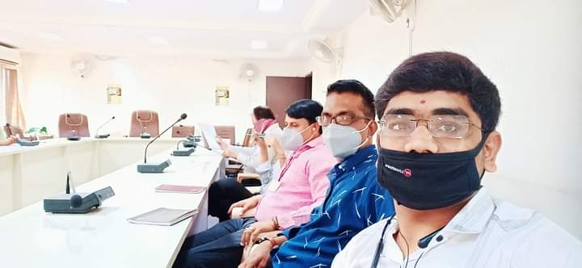
Meeting attend by NSS program officer, (Prof.) D.K.Mehta and campus ambassador Jay Padaliya.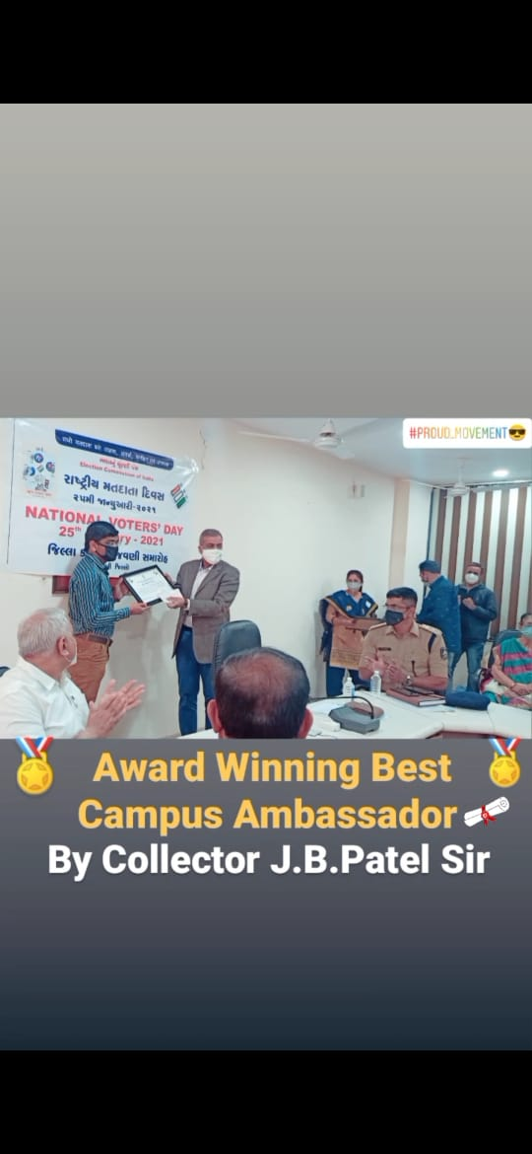

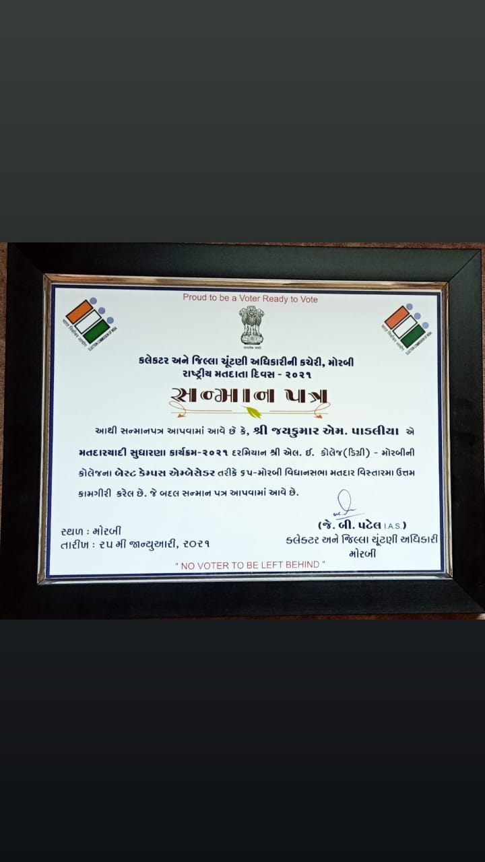
Certificate of appreciation

Upload Report in both WORD and PDF format

